What Caused the Dust Bowl?
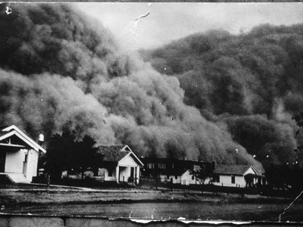
Dust storm approaching Stratford, Texas, April 18, 1935. NOAA Photo Library, Historic NWS Collection

Overview: In the 1930s America was hit by very bad times. These were the years of the Great Depression. In cities and in small towns across the land, banks were failing, businesses were closing, and workers were being fired. But in some ways farmers were hit hardest of all, and few farmers were hit harder than those in the Southern Great Plains. This region has come to be known as the Dust Bowl. The question for this Mini-Q is what caused the Dust Bowl tragedy.
The Documents:
Document A: Dusters
Document B: Grass
Document C: Fred Folkers and his tractor (with photograph)
Document D: Rainfall on the Plains in the 1930s
The Background: The granddaddy duster had struck on April 14, 1935. In Baca County, Colorado, they called it Black Sunday and it just about did everybody in. Now it was late May and the Osteen family had a decision to make. The little dugout with its dirt floors had been home to nine children. Not with father dead and the older kids mostly gone, it was just mom, Ike, his older brother Oscar and the two girls. Mom had already said she was walking away and taking the girls to live in town. Oscar and Ike could have the 320- acre farm. She was through with it. Ike had just graduated second in his class at Walsh High School and had given a little speech about how he loved Baca. He was the first Osteen ever to graduate from high school. But now what to do? Oscar said he was staying. He didn’t know anything else and some day the rains would come back. The orchard was all dead but the elm tree was still alive… and so was the mule.

Decision: You are Ike Osteen. You are 17 years old. It is dawn on May 28, 1935. You have a bundle of clothes tied up in an old shirt, a paper bag with two jackrabbit sandwiches, and a canteen of water. You are sitting at the table writing a note to Oscar saying he can have the farm, that you are walking up to Springfield to try to get a job with the railroad. But you stop writing. Is this what you really want to do? The job is a long shot. You look out the open door at the fields of dust and dirt. You don’t have a dollar to your name.

Your Task: With a partner talk through Ike’s situation. Will you leave? You love your brother but you’ve got to be true to yourself. On your answer sheet, Write down your reasons for leaving or staying.

What Caused the Dust Bowl?
On Thursday, April 18, 1935, a huge, black, billowing cloud piled up on the western horizon. For Stratford, Texas, and thousands of farms and small towns, it was the arrival of another dust storm, one of more than 300 that would make an unwelcome visit to the Southern Great Plains during the 1930s.
For thousands of years the Southern Great Plains were covered by shortgrass prairie and home to vast herds of twenty or thirty million buffalo. In more recent times, people arrived. First came the Apache, the Comanche, and the Kiowa. Shortly after the Civil War, there came a few thousand cowboys and several million cattle. Then came the farmer.
The first farmers arrived in the 1880s. Word had gotten out back East that the Southern Great Plains was good for wheat. Yes, rainfall was a bit spotty, but the land was cheaper than farmland in Arkansas or Illinois. Besides, it was said that rain would follow the plow. Grow crops and clouds would form.
With few trees for lumber, many of these early farmers lived in soddies, houses made of earth and grass. Soddies were soon replaced by word frame houses. A severe drought in the 1890s caused some farmers to move away, but then the federal government sweetened the pot. A new Enlarged Homestead Act passed in 1909 offered 320 acres of land to anyone who could hang on for three years. Thousands of new farm families took up the offer. In addition, the giant XIT ranch on the Texas panhandle sold off much of its three million acre spread to wanna-be farmers. Wheat would replace cattle as the new king of the Southern Plains.
Wheat fever was in the air. The railroad sent out branch lines to small towns, and more what could get to market. World War I, which brought so much pain to Europe, was good for Plains farmers. A hungry Europe bought Kansas wheat. Wheat that sold for 93 cents a bushel in 1914 was close to $2.50 in 1919. More families moved in. Small towns popped up like spring flowers. Boise City out near the end of the Oklahoma panhandle sported a theater, a newspaper, a furniture store, a bank, and several cafes.
But then trouble came. The Great Depression of the 1930s was the first blow. Unemployment back East made it harder to sell wheat. Sadly, the Depression did not come alone. What made life on the Southern Plains almost unbearable were the dust storms. In the middle thirties these wind-driven dusters darkened the midday sky and carried off millions of tons of precious topsoil as far as Washington DC and New York City. During the 1930s more than three million plains settlers left their farms- some for town, some for a neighboring state, some for California. Many more, however, stayed put, covering their windows with a water-soaked sheet, eating jackrabbit stew at t kitchen table were an “eating “ cloth covered all the plates and drinking cups. Children died from breathing in dust. They called it “dust pneumonia.” Writer Timothy Egan has titled his book on Dust Bowl history as The Worst Hard Time.
But exactly what happened to cause this worst hard time? Examine the documents that follow and do your best to answer the questions before us: What Caused the Dust Bowl?

ANSWER THE BACKGROUND ESSAY QUESTIONS ON YOUR ANSWER SHEET

1929- US unemployment is 1.6 million
1932- US unemployment is 12.1 million
1933- Prohibition is repealed
1934- Rainfall in Dalhart, Texas under 10 inches
1935- Solid Conservation Service created to stop erosion in Dust Bowl
1935- Jesse Owens wins four gold medals in Olympics in Nazi Berlin
1939- John Steinbeck’s Grapes of Wrath is published
Document A
Source: Donald Worster, Dust Bowl, The Southern Plains in the 1930s, Oxford University Press, 1979.
The story of the southern plains in the 1930s is essentially about dust storms, when the earth ran amok. And not once or twice, but over and over for the better part of a decade: day after day, year after year, of sand rattling against the window, of fine powder caking one’s lips, of springtime turned to despair. . .

In the memory of older plains residents, the blackest year was 1935. . . . On 15 March, Denver reported that a serious dust storm was speeding eastward. Kansans ignored the radio warnings, went about their business as usual, and later wondered what had hit them. Small town printer Nate White was at the picture show when the dust reached Smith Center: as he walked out the exit, it was as if someone had put a blindfold over his eyes: he bumped into telephone poles, skinned his shins on boxes and cans in the alleyway, fell to his hands and knees, and crawled along the curbing to a dim houselight. . . .

Livestock and wildlife did not have even . . . crude defenses. “In a rising sand storm,” wrote Margaret Bourke-White, “cattle quickly become blinded. They run around inc circles until they fall and breathe so much dust that they die. Autopsies show their lungs caked with dust and mud.” . . .

Avis Carlson told what it was like at night: “A trip to water to rinse the grit from our lips. And then back to bed with washcloths over our noses. We try to lie still, because every turn stirs the dust on the blankets. After a while, if we are good sleepers, we forget.”

Document B
Source: Texas sheepherder, in Stuart Chase, Rich Land, Poor Land, New York, McGraw-Hill, 1936.
“Grass is what counts. It’s what saves us all- far as we get saved. . . . Grass is what holds the earth together.”
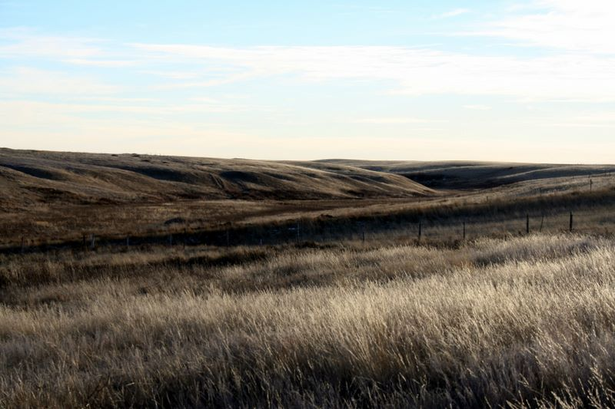
The most common short grass in the Dust Bowl region was buffalo grass. It only grew about four inches high and produced a tough grassy mat that looked like a well-grazed meadow.

Document C
Source: Timothy Egan, The Worst Hard Time, Houghton Mifflin Company, New York, 2006.
With a horse-drawn plow, Fred Folkers produced nearly enough to stay afloat. What changed everything for hinm, and other dryland farmers, was the tractor . . . . A tractor did the work of ten horses. With his new combine, Folkers could cut and thresh the grain in one swoop, using just a fraction of the labor . . . . Folkers plowed nearly his entire square mile, and then paid to rent nearby property and ripped up that grass as well. By the late 1920s, his harvest was up to ten thousand bushels of wheat- a small mountain of grain. What’s more, there was now an easy way to get the wheat of Fred Folkers. . . . to the rest of the world. In 1925, a train finally arrived in Boise City . . . .

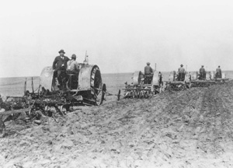
Wheat king Simon Fishman (in coat and tie) and his employees working the land. Greeley County, Kansas, 1925.

Document D
Source: Great Plains Drought Area Committee Report of August 27, 1936, Washington DC. US Government Printing Office.
Note: This committee was formed at the request of President Franklin Roosevelt.

Document E
Source: High Plains Regional Climate Center, University of Nebraska, Lincoln, Nebraska
Normal Annual Precipitation for Five Dust Bowl Towns
Town Normal Precipitation (inches)
Clovis, New Mexico 17.64
Boise City, Oklahoma (panhandle) 17.00
Dalhart, Texas (panhandle) 17.87
Burlington, Colorado 16.38
Goodland, Kansas 18.02

Note: John Wesley Powell, the great Western explorer, determined that 20 inches of rain annually was the minimum for successful farming on the Plains. But, he said, “. . . at 20 inches agriculture will not be uniformly successful from season to season.”

Source: From Randy Francis, Source: From Randy Francis, The Texas Dust Bowl in Historical Perspective, Baylor University, Waco, Texas, 1998.
Actual Precipation for Dallam County, Texas
(County Seat, Dalhart)
1923 33.40
1924 15.32
1931 14.66
1932 20.09
1933 10.14
1934 9.78
1935 13.31
1936 9.93
1937 14.48
1939 14.75
1940 12.74

