Valley Forge: Would You have Quit?
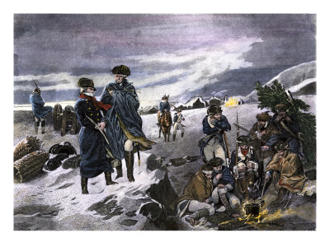
Overview: In the winter of 1777 and 1778, George Washington commanded several thousand patriot soldiers who spent the winter at Valley Forge, 18 miles outside of Philadelphia. It was not an easy time. This Mini-Q asks the question: If you had been a soldier in Washington’s army, would you have quit?
The Documents:
Document A: The Numbers: Deaths and Illness (chart)
Document B: Washington at Valley Forge (engraving)
Document C: Diary of Dr. Albigence Waldo
Document D: The Sunshine Soldier: Thomas Paine

The Historical Setting
Place: Montgomery County, Pennsylvania
Date: Mid-January, 1778
The Situation: Your name is Levi Zendi. Most folks call you “Uncle Levi.” You are a prosperous, third generation Pennsylvania Dutch Farmer with foodstuffs to sell. In September, the British army under William Howe occupied nearby Philadelphia and set up comfortable quarters for the winter. Last month, the American Continental Army under George Washington made its rough winter camp at Valley Forge, just a few miles west of your farm. You are a Quaker and hate war, but business is business.
Last week you sent your nephews to both camps to get prices offered by the two armies. They returned with this price list.
Prices offered Uncle Levi (Friday last)
By the Army at Valley Forge By the British in Philadelphia
Butter (one pound) 3 shillings plus 7 shillings
Potatoes (one bushel) 10 shillings 16 shillings
Veal (one pound) 1 shilling 4 shillings

To which army are you going to sell your foodstuffs? Why?

If most of your neighbors do as you do, what impact will it have on the American army at Valley Forge?

Background Essay: Valley Forge: Would You Have Quit?

The first two years of the American Revolution had not gone well for the Continental Army. Since the summer of 1775 when he had taken command, George Washington and his troops had withdrawn from Boston and retreated from New York City. Most recently, in October 1777, he had been unable to stop the British when General Howe marched his army into the national capital of Philadelphia. True, there had been a victory at Trenton and a success at Princeton, but on the whole Washington’s army had seen hard times.
Not surprisingly, Washington was having trouble keeping his soldiers in the army. Some of his men had signed on for one or two years. However, the most frequent time of enlistment was nine months. Nine-month men were going home and not returning. Others simply deserted.
To make matters worse, Washington’s own position was uncertain. Some members of Congress did not trust him. To them, the general from Virginia seemed to be leading a grand retreat.
Like much of America, Philadelphia was divided over the war. Some Philadelphians even welcomed the British. A few young women developed ‘scarlet fever,’ a fascination with British soldiers and their bright red coats. Washington’s own Chief of Engineers wrote that, “There is a hundred times more enthusiasm for this revolution… in Paris than there is in all the United States together.”
With Howe’s army of 18,000 comfortably quartered in Philadelphia, Washington decided to build a winter camp at Valley Forge about 18 miles northwest.
It was not big enough to be called a village, with only a few fieldstone houses, and a mill for forging iron. The Quaker farms in the area offered the promise of food for his men, and the camp would be close enough to Philadelphia to keep an eye on the British.
It was a week before Christmas, 1777. The first job of the men was to build log “huts.” Each hut was 16’ by 14’ with a door at one end, a stick and clay fireplace at the other, and no windows. Each hut slept twelve men. There were no beds, just straw on the mud floor. Cold was one problem, smoke was another. The huts would be home for the next six months.
Some of the conditions experienced by the soldiers at Valley Forge are revealed in the four documents that follow. Today we know that most of the army survived the winter. We also know that on April 13, 1778, word reached camp that the French would join the Americans in the war. It was a huge turning point. But what we know today was not known in late December, 1777. Victory seemed a long way off, in fact for many, it seemed unlikely.
Now it is time to look into your own heart of hearts. Your 9-month enlistment is up on February 1st, just one month away. General Washington is desperate to keep his army intact. You miss your family and are concerned about your aging mother. Examine the documents that follow and answer the question: Had you been a soldier at Valley Forge, would you have quit?

Background Essay Questions

1. In December of what year did Washington and his troops arrive in Valley Forge?
2. How many miles is Valley Forge from Philadelphia?
3. Define or explain each of the following terms:
Continental Army desert “scarlet fever’
Valley Forge Quaker huts
4. What is the main idea of the quotation by Washington’s chief of Engineers?

Document A
Source: Varied sources including Noel F. Busch, Winter Quarters, Liveright, New York, 1974.
Estimates of Illness and Deaths at Valley Forge
(December 1777- February 1778)
__________________________________________
Total Soldiers at Valley Forge (estimates) December 1777 12,000
February 1778 8,000
__________________________________________
Illness Estimates During Encampment*
December 23,1777 2,898
February 1, 1778 3989
__________________________________________
Death Estimates Due to Illness During Encampment
December-June 1,800-2,500
__________________________________________
*Reported sick or unable to report for duty
Document Analysis
1. Is this document a primary or secondary source? Explain your thinking
2. On February 1, 1778, how many soldiers at Valley Forge were sick? What % was this?
3. What was the low estimate of the number of American soldiers who died at Valley Forge?
4. How could this document be used to argue for quitting?
5. How could this document be used to argue against quitting?

Document B
Source: Engraving of a painting by William Henry Powell, Committee of Congress at Valley Forge, National Archives, 1866.
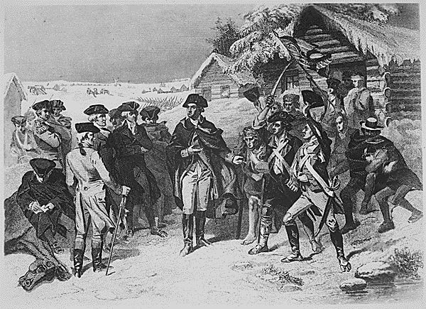
George Washington presenting Congressional Committee to soldiers at Valley Forge
Document Analysis
1. In what year was this engraving done?
2. Who are the men at the left? The men at the right? The man in the middle?
3. What do you suppose the man in the middle was saying?
4. How could this document be used to argue for quitting?
5. How could this document be used to argue against quitting?
Document C
Source: Diary of Dr. Albigence Waldo, a Connecticut surgeon, 1777.
Note: Dr. Waldo suffered during the winter at Valley Forge but stayed loyal to the Continental Army as he helped other surgeons care for sick soldiers.

December 14, 1777
The Army which has been surprisingly healthy hitherto, now begins to grow sickly from
the continued fatigues they have suffered this Campaign. Yet they still show a spirit of
Alacrity (cheerful willingness) and Contentment not to be expected from so young Troops.
I am Sick- discontented- and out of humour. Poor food- hard lodging- Cold weather- fatigue-
nasty Cloaths- nasty Cookery- Vomit half my time- smoak’d out my senses- the Devil’s in’t-
I can’t Endure it- Why are we sent here to starve and Freeze… There comes a Soldier, his
bare feet are seen thro’ his worn out Shoes, his legs nearly naked from the tatter’d remains
of an only pair of stockings…

December 21. 1777
“Heartily wish myself at home, my Skin and eyes are almost spoil’d with continual smoke. A
General cry thro’ the Camp this Evening among the Soldiers, “No Meat! No Meat!” – the
Distant vales Echo’d back the melancholy sound - “No Meat! No Meat!”

Document Analysis
1. Do you believe this document is an accurate picture of camp life at Valley Forge? Why?
2. What hardship described by Waldo most gets your attention?
3. Make one inference about the quality of ventilation in the soldiers’ huts.
4. How could this document be used to argue for quitting?
5. How could this document be used to argue against quitting?

Document D
Source: Thomas Paine, The American Crisis, December 23, 1776.
Note: General Washington had essays from The American Crisis read aloud to his soldiers at Valley Forge. Paine, known by some as the author of the Revolution, took no payment for this historic publication.

“These are the times that try men’s souls. The summer soldier and the sunshine patriot
will, in this crisis, shrink from the service of their country; but he that stands it now,
deserves the love and thanks of man and woman. Tyranny, like hell, is not easily conquered;
yet we have this consolation with us, that the harder the conflict, the more glorious the triumph. What we obtain too cheap, we esteem too lightly; it is dearness only that gives every thing its value…Britain, with an army to enforce her tyranny, has declared that she has a right (not
only to TAX) but ‘to BIND us in ALL CASES WHATSOEVER.’ And if being bound in that
manner, is not slavery, then is there not such a thing as slavery on earth.”

Document Analysis
1. When was this document written and who was the author?
2. What is meant by the line, “These are the times that try men’s souls”?
3. Who are “The summer soldier and the sunshine patriot”?
4. What is “tyranny” and what does Paine compare it to?
5. What does Paine mean when he writes, “What we obtain too cheap, we esteem too lightly”?
6. What is the main idea of this document?
7. Are the words of Thomas Paine enough to keep you at Valley Forge?

